Used Car Price Prediction — Data Science Intern Project
This notebook builds a machine learning workflow to predict used car resale prices in India (in ₹ Lakhs). Naming Convention: All user-defined variables, DataFrame column names, functions, and saved files strictly avoid using underscores (_).
Step 1: Import Libraries and Generate Synthetic Dataset
We generate a realistic dataset of 1,500 Indian used cars across 6 popular brands (Maruti, Hyundai, Tata, Honda, Toyota, Mahindra).
import pandas as pd
import numpy as np
import pickle
import matplotlib.pyplot as plt
from sklearn.model_selection import train_test_split
from sklearn.preprocessing import OneHotEncoder
from sklearn.compose import ColumnTransformer
from sklearn.pipeline import Pipeline
from sklearn.linear_model import LinearRegression
from sklearn.ensemble import RandomForestRegressor
from sklearn.metrics import r2_score, mean_absolute_error, mean_squared_error

np.random.seed(42)
samplesize = 1500

brandlist = ['Maruti', 'Hyundai', 'Tata', 'Honda', 'Toyota', 'Mahindra']
fuellist = ['Petrol', 'Diesel', 'CNG', 'Electric']
translist = ['Manual', 'Automatic']

carbrand = np.random.choice(brandlist, size=samplesize)
modelyear = np.random.randint(2010, 2027, size=samplesize)
kmdriven = np.random.randint(5000, 200000, size=samplesize)
fueltype = np.random.choice(fuellist, size=samplesize, p=[0.45, 0.35, 0.12, 0.08])
transmission = np.random.choice(translist, size=samplesize, p=[0.65, 0.35])
ownercount = np.random.choice([1, 2, 3], size=samplesize, p=[0.70, 0.22, 0.08])

# Base valuation logic in Lakhs (INR)
brandbase = {'Maruti': 6.5, 'Hyundai': 8.0, 'Tata': 8.5, 'Honda': 9.5, 'Toyota': 14.5, 'Mahindra': 12.5}
fuelbonus = {'Petrol': 0.0, 'Diesel': 1.2, 'CNG': 0.4, 'Electric': 2.5}
transbonus = {'Manual': 0.0, 'Automatic': 1.5}

sellingprice = []
for idx in range(samplesize):
baseval = brandbase[carbrand[idx]]
age = 2026 - modelyear[idx]
agefactor = (0.91 ** age)
kmfactor = max(0.4, 1.0 - (kmdriven[idx] / 320000.0))
ownerpenalty = (ownercount[idx] - 1) * 0.45

estimated = (baseval * agefactor * kmfactor) + fuelbonus[fueltype[idx]] + transbonus[transmission[idx]] - ownerpenalty
noise = np.random.normal(0, 0.35)
finalval = max(1.10, round(estimated + noise, 2))
sellingprice.append(finalval)

cardata = pd.DataFrame({
'carbrand': carbrand,
'modelyear': modelyear,
'kmdriven': kmdriven,
'fueltype': fueltype,
'transmission': transmission,
'ownercount': ownercount,
'sellingprice': sellingprice
})

print('Dataset Shape:', cardata.shape)
cardata.head(10)
Dataset Shape: (1500, 7)
 | carbrand | modelyear | kmdriven | fueltype | transmission | ownercount | sellingprice
0 | Honda | 2015 | 49014 | CNG | Manual | 1 | 3.22
1 | Toyota | 2011 | 147810 | Diesel | Manual | 1 | 3.02
2 | Tata | 2021 | 99333 | Petrol | Manual | 1 | 3.97
3 | Toyota | 2014 | 183570 | Diesel | Automatic | 1 | 4.48
4 | Toyota | 2021 | 16120 | Diesel | Manual | 1 | 10.21
5 | Hyundai | 2026 | 144839 | Petrol | Manual | 2 | 4.24
6 | Tata | 2026 | 27852 | Petrol | Manual | 1 | 8.40
7 | Tata | 2019 | 84239 | Electric | Manual | 1 | 5.49
8 | Tata | 2026 | 137001 | CNG | Automatic | 1 | 7.24
9 | Toyota | 2024 | 96575 | CNG | Automatic | 1 | 10.48
Step 2: Exploratory Data Analysis (EDA)
Inspect summary statistics, missing values, and brand-wise average resale prices.
print('Missing Values Check:')
print(cardata.isnull().sum())

print('\nSummary Statistics:')
print(cardata.describe().round(2))

brandavg = cardata.groupby('carbrand')['sellingprice'].mean().sort_values(ascending=False)
print('\nAverage Selling Price by Brand (in Lakhs):')
print(brandavg.round(2))
Missing Values Check:
carbrand 0
modelyear 0
kmdriven 0
fueltype 0
transmission 0
ownercount 0
sellingprice 0
dtype: int64

Summary Statistics:
modelyear kmdriven ownercount sellingprice
count 1500.00 1500.00 1500.00 1500.00
mean 2018.00 103029.38 1.39 4.52
std 4.91 56461.22 0.62 2.38
min 2010.00 5138.00 1.00 1.10
25% 2014.00 53963.00 1.00 2.78
50% 2018.00 103642.00 1.00 4.09
75% 2022.00 153111.50 2.00 5.79
max 2026.00 199994.00 3.00 16.61

Average Selling Price by Brand (in Lakhs):
carbrand
Toyota 5.96
Mahindra 5.60
Honda 4.45
Tata 3.92
Hyundai 3.84
Maruti 3.38
Name: sellingprice, dtype: float64
plt.figure(figsize=(12, 4))

plt.subplot(1, 2, 1)
brandavg.plot(kind='bar', color='#2563eb', edgecolor='black')
plt.title('Average Resale Price by Brand (Lakhs)')
plt.ylabel('Price (INR Lakhs)')
plt.xticks(rotation=30)

plt.subplot(1, 2, 2)
plt.scatter(cardata['modelyear'], cardata['sellingprice'], alpha=0.4, color='#059669')
plt.title('Selling Price vs Model Year')
plt.xlabel('Model Year')
plt.ylabel('Price (INR Lakhs)')

plt.tight_layout()
plt.show()
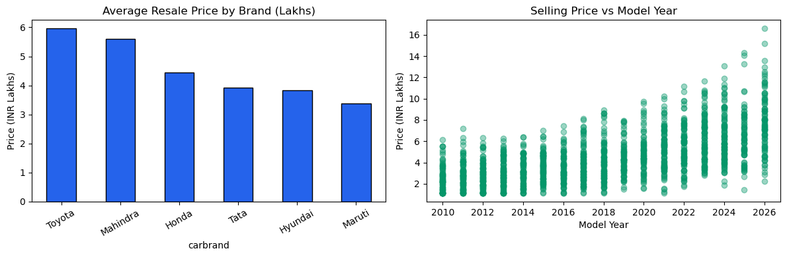
Step 3: Preprocessing Pipeline & Model Training
We split the dataset into training and testing subsets and compare Multiple Linear Regression with Random Forest Regressor.
features = cardata[['carbrand', 'modelyear', 'kmdriven', 'fueltype', 'transmission', 'ownercount']]
target = cardata['sellingprice']

xtrain, xtest, ytrain, ytest = train_test_split(features, target, test_size=0.2, random_state=42)

categoricalcols = ['carbrand', 'fueltype', 'transmission']
preprocessor = ColumnTransformer(
transformers=[
('catencoder', OneHotEncoder(handle_unknown='ignore'), categoricalcols)
],
remainder='passthrough'
)

# 1. Linear Regression Pipeline
linearpipeline = Pipeline(steps=[
('preprocessor', preprocessor),
('regressor', LinearRegression())
])

linearpipeline.fit(xtrain, ytrain)
linearpreds = linearpipeline.predict(xtest)

linearr2 = r2_score(ytest, linearpreds)
linearmae = mean_absolute_error(ytest, linearpreds)
linearrmse = np.sqrt(mean_squared_error(ytest, linearpreds))

# 2. Random Forest Regressor Pipeline
forestpipeline = Pipeline(steps=[
('preprocessor', preprocessor),
('regressor', RandomForestRegressor(n_estimators=120, random_state=42))
])

forestpipeline.fit(xtrain, ytrain)
forestpreds = forestpipeline.predict(xtest)

forestr2 = r2_score(ytest, forestpreds)
forestmae = mean_absolute_error(ytest, forestpreds)
forestrmse = np.sqrt(mean_squared_error(ytest, forestpreds))

comparison = pd.DataFrame({
'Model': ['Linear Regression', 'Random Forest Regressor'],
'R2Score': [round(linearr2, 4), round(forestr2, 4)],
'MAE (Lakhs)': [round(linearmae, 4), round(forestmae, 4)],
'RMSE (Lakhs)': [round(linearrmse, 4), round(forestrmse, 4)]
})

print('Model Evaluation Summary:')
print(comparison.to_string(index=False))
Model Evaluation Summary:
Model R2Score MAE (Lakhs) RMSE (Lakhs)
Linear Regression 0.8929 0.6055 0.8532
Random Forest Regressor 0.9281 0.5061 0.6991
Step 4: Custom Prediction Function & Model Serialization
Define predictprice() with zero underscores and export the trained pipeline to carpricemodel.pkl.
def predictprice(brandval, yearval, kmval, fuelval, transval, ownerval):
sampleinput = pd.DataFrame([{
'carbrand': brandval,
'modelyear': yearval,
'kmdriven': kmval,
'fueltype': fuelval,
'transmission': transval,
'ownercount': ownerval
}])
predictedval = forestpipeline.predict(sampleinput)[0]
return round(float(predictedval), 2)

# Test prediction
sampleestimate = predictprice('Hyundai', 2021, 38000, 'Petrol', 'Automatic', 1)
print(f'Estimated Price for 2021 Hyundai (Automatic, Petrol, 38k km): Rs. {sampleestimate} Lakhs')

# Save trained model pipeline
with open('carpricemodel.pkl', 'wb') as modelfile:
pickle.dump(forestpipeline, modelfile)

print('Saved trained pipeline as carpricemodel.pkl')
Estimated Price for 2021 Hyundai (Automatic, Petrol, 38k km): Rs. 6.44 Lakhs

